Working with Docker Commands and Docker Hub

1. Pull latest nginx image from Docker hub

# docker pull nginx

Using default tag: latest
latest: Pulling from library/nginx
45b42c59be33: Pull complete
8acc495f1d91: Pull complete
ec3bd7de90d7: Pull complete
19e2441aeeab: Pull complete
f5a38c5f8d4e: Pull complete
83500d851118: Pull complete
Digest: sha256:f3693fe50d5b1df1ecd315d54813a77afd56b0245a404055a946574deb6b34fc
Status: Downloaded newer image for nginx:latest
docker.io/library/nginx:latest

2. Check if image have been downloaded

# docker images
REPOSITORY TAG IMAGE ID CREATED SIZE
nginx latest 35c43ace9216 2 weeks ago 133MB

3. Create nginx container from the image

# docker run -d nginx:latest
7c6e7c6730b94de9a7c92809989d73c7a55303614da25ba34b86419e259275db

4. Check if nginx container has been created
# docker ps or docker container ls

CONTAINER ID IMAGE COMMAND CREATED STATUS PORTS NAMES
7c6e7c6730b9 nginx:latest "/docker-entrypoint.…" About a minute ago Up About a minute 80/tcp objective_sinoussi

5. Check the ipaddress details of the container by using docker inspect command

#docker inspect 7c6e7c6730b9 | grep -i ip

"IpcMode": "private",
"LinkLocalIPv6Address": "",
"LinkLocalIPv6PrefixLen": 0,
"SecondaryIPAddresses": null,
"SecondaryIPv6Addresses": null,
"GlobalIPv6Address": "",
"GlobalIPv6PrefixLen": 0,
"IPAddress": "172.17.0.2",
"IPPrefixLen": 16,
"IPv6Gateway": "",
"IPAMConfig": null,
"IPAddress": "172.17.0.2",
"IPPrefixLen": 16,
"IPv6Gateway": "",
"GlobalIPv6Address": "",
"GlobalIPv6PrefixLen": 0,

6. Logon to the nginx container and create some sample files

# docker exec -it 7c6e7c6730b9 bash
touch example.txt
# ls
bin dev docker-entrypoint.sh example.txt lib media opt root sbin sys usr
boot docker-entrypoint.d etc home lib64 mnt proc run srv tmp var

Ctrl+P+Q

7. Stop the container and again login and check if the example.txt file still exists

docker stop 7c6e7c6730b9

docker start 7c6e7c6730b9

# docker exec -it 7c6e7c6730b9 bash
ls
apt-get update
apt-get install vim
vim example.txt

Pushing container changes to Docker Hub

1. Commit the container changes to a local image

# docker commit 7c6e7c6730b9 img01
sha256:6520e6642eeb4dc88fea260645e35888a775f396c826540948571060a16a2377

2. Check if img01 has been created

# docker images

REPOSITORY TAG IMAGE ID CREATED SIZE
img01 latest 6520e6642eeb 27 seconds ago 133MB
nginx latest 35c43ace9216 2 weeks ago 133MB

3. Create a Public repository named as repo0603 in Docker Hub

4.Tag local repository to repository named repo0603 in Docker Hub

# docker tag img01 chaitanyagaajula/repo0603:nginximage

5.Check if image has been tagged

# docker images

REPOSITORY TAG IMAGE ID CREATED SIZE
chaitanyagaajula/repo0603 nginximage 6520e6642eeb 2 minutes ago 133MB
img01 latest 6520e6642eeb 2 minutes ago 133MB
nginx latest 35c43ace9216 2 weeks ago 133MB

6.Authenticate to dockerhub

# docker login
Login with your Docker ID to push and pull images from Docker Hub. If you don't have a Docker ID, head over to https://hub.docker.com to create one.
Username: chaitanyagaajula
Password:
WARNING! Your password will be stored unencrypted in /root/.docker/config.json.
Configure a credential helper to remove this warning. See
https://docs.docker.com/engine/reference/commandline/login/#credentials-store
Login Succeeded

7.Push the image to repository dockerhub

# docker push chaitanyagaajula/repo0603:nginximage
The push refers to repository [docker.io/chaitanyagaajula/repo0603]
032fe9ab5172: Pushed
2acf82036f38: Layer already exists
9f65d1d4c869: Layer already exists
0f804d36244d: Layer already exists
9b23c8e1e6f9: Layer already exists
ffd3d6313c9b: Layer already exists
9eb82f04c782: Layer already exists
nginximage: digest: sha256:c6e21f23264701cdd4a7f91f84ead23b63bf6c84ee70889e94075d4ae24518a2 size: 1777

8. Check if image has been pushed to docker
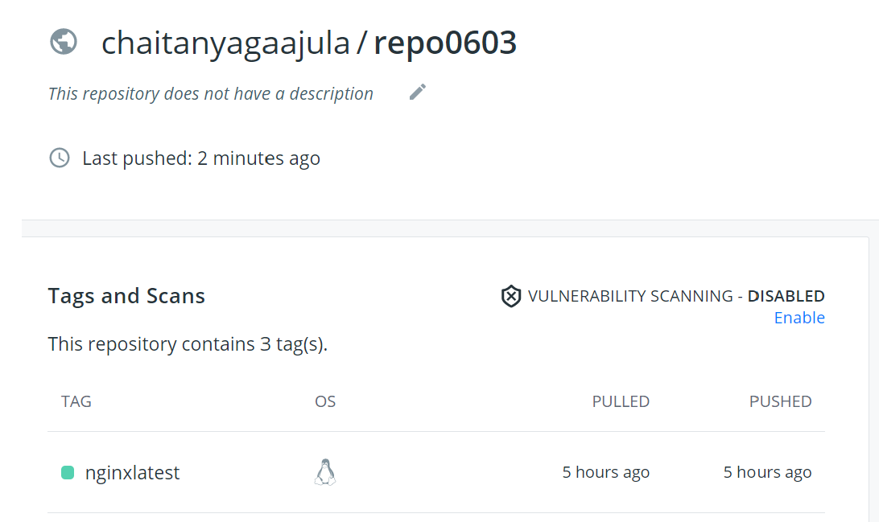

9. Check if other team members are able to see the example.txt in the container which they created from the image.
# docker pull chaitanyagaajula/repo0603:nginxlatest
# docker run -d chaitanyagaajula/repo0603:nginxlatest
# docker exec -it containername bash
ls
example.txt

